Mercury House

Regulation 16, Schedule 1

Statement of Purpose

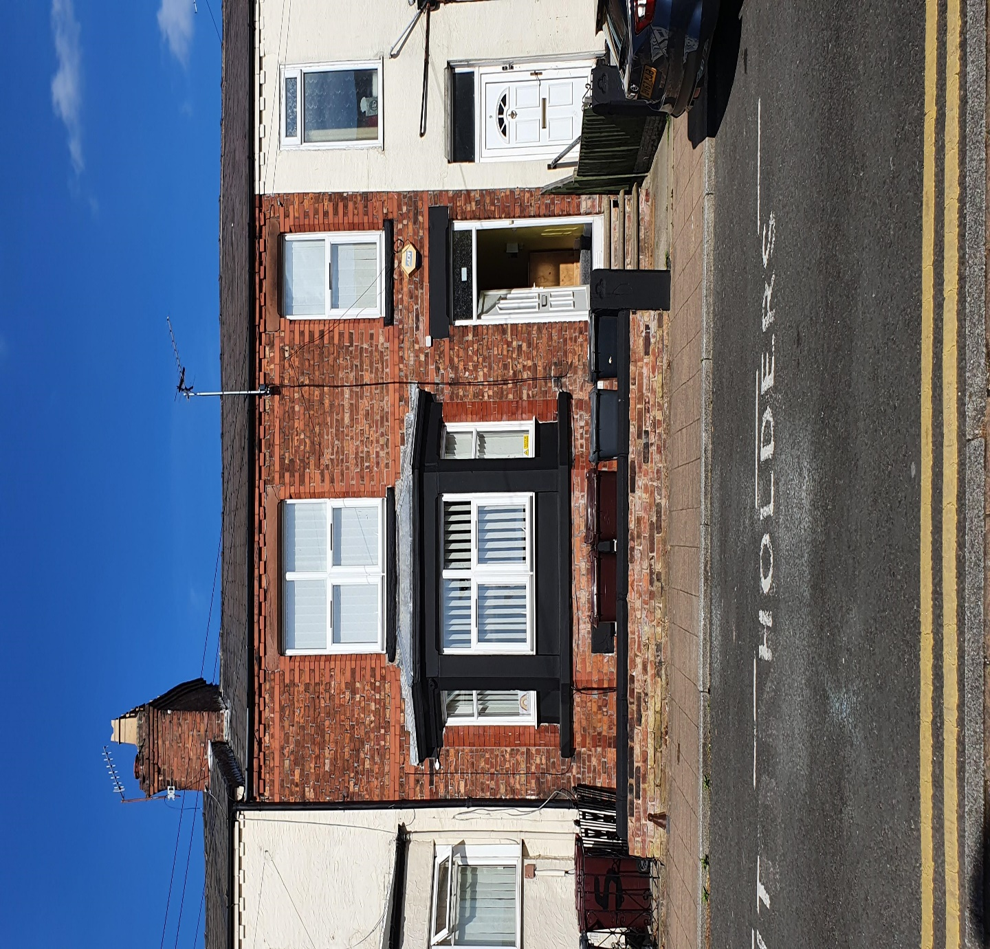

|  |  |
| --- | --- |
| **Name of Children’s Home:** | Mercury House |
| **Address:** | 7 Station Road, Prescot, L34 5SN |
| **Ofsted Registration:** | 1062186 |
| **Company:** | Omega Care Group Ltd |
| **Interim Appointed Manager:** | Nicole Whiting |
| **Telephone Number:** | 07554 238875 |
| **Email:** | n.whiting@omegacaregroup.org |
| **Responsible Individual:** | Alex Aresti |

**Contents**

Table of Contents

Omega Care Group’s Commitment 4

Quality and Purpose of Care 5

**Introduction to Mercury House** 5

**The ethos and outcomes and how we will achieve them** 5

**Facilities offered by the home** 7

**Floor plans of Mercury House** 8

**Location of the home** 9

**Supporting cultural, linguistic and religious needs** 9

**Complaints and being heard:** 11

**Safeguarding policy and behaviour development management policy** 12

Views, Wishes and Feelings 15

**Consulting with children and young people** 15

**Anti-discrimination and families and children’s rights** 16

Education 17

**Supporting children and young people with special educational needs** 17

**Education curriculum and the arrangements for education** 17

**Promoting educational achievement** 18

Enjoyment and Achievement 19

**Social outcomes** 19

Health and Wellbeing 20

**Health outcomes** 21

**Training** 21

**Medication** 21

**Exercise** 21

**Diet** 21

**Personal Hygiene** 22

**Smoking** 22

**Alcohol and Drug Misuse** 22

**Sexual Health** 22

**Health Education** 22

**Therapy** 23

Positive Relationships 23

**Promoting contact between children, their families and friends** 23

Protection of Children 24

**Approach to monitoring and surveillance** 24

**Behaviour Support Plan** 24

**Sanctions or Consequences** 25

**Room Search** 26

**Safeguarding:** 26

**Managing Risk-children and young people:** 27

**Supporting Positive Behaviours: (reference: Behavioural Development Policy and Restrictive Physical Intervention Policy)** 27

**Our Approach to Restrictive Physical Intervention (RPI)** 27

**Missing Child Policy: (Reference: Policy document)** 28

**Anti-Bullying: (Reference: Anti-Bullying Policy)** 29

**Care Planning:** 29

**Care and Control** 29

Leadership and Management 30

**Registered Provider, Responsible Individual, Service Manager and Registered Manager’s contact details** 30

**Experience and qualifications of staff** 32

**Management and staffing structure, and support** 33

**Mercury House Staff Structure** 33

33

**Bank/Cover Staff** 33

**Staffing Rationale** 34

**Promoting appropriate staff role models** 34

Care Planning 35

**Admission criteria and policy** 35

**Admission of young people subject to a Deprivation of Liberty (DOL) Order** 36

Appendix 1. Staffing Qualifications and Experience 37

Appendix 2. Statement of Purpose Amendment Log 39

# Omega Care Group’s Commitment

At Omega Care Group, we believe:

* Every child and young person have a right to a physically and emotionally safe home environment where they can flourish.
* All children and young people have the right to meaningful, person centred support on their personal journey.
* Every child and young person should be enabled to realize their full potential and more.
* Our mission statement:

Growth through potential,

Valued, nurtured, realised

roots for the future.

Growth through potential, Valued, nurtured, realised roots for the future:

* No child or young person should be disadvantaged by their life background, adverse childhood experiences or their lived experience.
* Every child and young person have a right to develop their self-identity, to be an individual before risk or diagnoses and to be valued for who and what they are and what they bring.
* All work in Mercury House is inspired from meaningful, professional, mutually trust based relationships underpinned by coherency and consistency of approach, ‘one page, one voice’.
* Effective collaborative working enables a holistic engaged and positive response to the emerging needs of the child and young person.

Quality and Purpose of Care Regulation 6

## **Introduction to Mercury House**

Mercury House is an Ofsted registered children’s home located in a residential area in Prescot. The home is managed and run by Omega Care Group.

Mercury House will provide residential care for children and young people aged between 10-17 years of age with social, emotional and behavioural difficulties were breakdown in home or foster placement is no longer suitable due presenting behaviours or the degree of vulnerability. The home will accommodate up to three children or young people via a suitable matching process.

The home is equipped to care with children and young people who experience these difficulties through training, nurture and planned care with other professionals.

Mercury House offers long-term placement with the intent to progress with the child or young person towards adulthood. The delivery of service will be defined by the identified parameters within the child or young person’s care plan and placement plan developing their individual needs.

Accommodation at Mercury House is a positive choice for young people where residential care is a preferred choice to meet their needs.

The Registered Manager, Service Manager and Responsible Individual will only accept placements for children where they are satisfied that the home can respond effectively to the child’s assessed needs, as record in the child’s relevant plans, these decisions will be recorded in impact risk assessments.

The home can offer a medium to long term placement for a child or young person of either gender. Once placed at Mercury House, our main purpose and aims for the young person will be as follows:

* Immediate stabilisation
* Emotional and cognitive re-regulation
* Beginning to build relationships and initial attachments
* Teaching and modelling self-regulation and self-soothing skills
* Increasing self-awareness and skill development
* Adapt to group living settings
* Keeping the young person safe
* Give the young person the opportunity to enjoy and achieve
* Try to ensure that they reach their potential and that their experiences within the home are positive.

Our commitment is to provide an emotionally and physically safe home environment using person-centred approaches to promote personal and social development promoting positive decision making and the self-management of behaviours and risk.

## **The ethos and outcomes and how we will achieve them**

Mercury House is a multi-bed provision with a child and young person focus. We promote positive, solution-based approaches and the achievement of targeted, meaningful outcomes.

We provide a high quality, homely environment within which the young person is enabled to realise the concept of a ‘safe and stable base’ and to develop their resilience within safe and consistent parameters.

Staff will demonstrate empathy in their practice and use both pro and re active approaches to emerging issues and in their response to wishes and feelings expressed by the young person. We aim to actively promote the ability of the young person to develop healthy relationships and to engage positively with their peers and the wider community. This approach is rooted in ensuring and enabling the young person to feel valued as a unique being, for them to feel secure within their home and the development of meaningful, trust- based relationships with the staff team.

To enable this, we will:

* Endorse this through the child and young person welcome guide and induction process to address expectations.
* Promote and maintain positive and consistent routines.
* Work in partnership with the young person and relevant others to manage and reduce risk factors and promote risk self-management.
* Respect and support the rights of the young person and ensure their voice is heard.
* Negotiate effective boundaries and positive learning experiences re: responsibilities.
* Ensure the young person has access to a range of opportunities to engage, to develop and to enjoy experiences.
* Actively promote positive choices and the processes that underpin this.

We offer a responsive, caring and values led environment which places the child and young person at the heart of all processes, decisions and activities within the home. Our practice is based on working in partnership with the young person, supporting them to realise their potential and promoting a positive sense of self-worth and personal identity.

We recognise and understand that the young people placed with us will have enhanced support needs and vulnerabilities. Staff are trained and supported in managing these constructively and in the promotion of the young person’s abilities to self-manage risk, develop coping strategies and to make positive choices promoting healthy personal development.

Staff will present positive role modelling, addressing unacceptable behaviours and risk taking with empathy and constructive intervention, whilst enabling and supporting the young person to expand their horizons and develop their personal growth.

The approach of the home is based on a step by step philosophy, with negotiated targets and boundaries providing the basis for incremental growth. Central to all our practice is the voice of the young person, and their right to express their views and feelings and to be heard. We use a range of tools to support this with the intent that the young person engages positively with their own development and bring their perspective to all matters that impact on them.

Staff operate within a whole team approach to promote a holistic, consistent and coherent home environment, this is supported by an emphasis on reflective practice and effective information sharing.

We operate within clear negotiated boundaries with restorative processes (a modified form of restorative justice) used to support the young person and their understanding of the impact of their behaviours (on themselves and others) and of potential consequences.

Diversity and Equality underpins all aspects of the work at Mercury House, with the individual young person valued for who and what they are and what they bring. Our commitment is to work with them to promote empowerment, personal growth, resilience and positive self-identity.

Mercury House operates effective risk management and safeguarding processes, delivered by an aware and knowledgeable staff team who will always act in the best interests of the young person.

## **Facilities offered by the home**

We offer a welcoming and supportive environment recognising that the child or young person cared for is valued as an individual. It is our belief that all children or young people are entitled to a high standard of care and we therefore aim to provide a physically and emotionally safe environment that is warm, homely and non-institutionalised that allows them to experience being a child within consistent, stable structures and boundaries.

Mercury House is a three bedroomed terraced property with a garden at the front and rear, offering an outdoor space. There is a lounge, dining area in basement with kitchen, bathroom, office, front of house reception room, utility room and staff sleep-in quarters.

The child or young person’s bedroom can be personalised to their taste as a personalisation bedroom allowance will be allocated. On admission, the child or young person is provided with a key to their own room and furniture where they can store their valuables and any self-administered medicines which will be risk assessed, providing there is no risk of significant harm. Bedrooms are checked once daily minimal by staff and the home’s earning and incentive program encourages children and young people to maintain a bedroom to a good standard.

The accommodation provides facilities for the child or young person to make telephone calls in private, to see visitors and to have contact in a safe setting. Access to the office telephone during school hours is limited to telephoning family members or key individuals and professionals involved in the child or young person’s care, however consideration will be given to suit the needs of the child and young person.

The home follows stringent Health and Safety (H&S) procedures which entails daily checks, monthly audits and risk assessments, annual management H&S risk assessment and a internal impartial risk assessment. The home also has window restrictors on all windows not located on the ground floor and has fire resistant doors throughout the property to minimise any fire risks.

There is a smart television in the lounge area and in the young person’s bedroom which is can be connected through the router and monitored 24/7 by the company’s IT Officer. Books are available to read, and a magazine subscription can be arranged to support the child or young person’s interests.

The child or young person’s bedroom will have a desk and chair on request for private study.

The home has a laptop for the children and young people to complete any homework or other activities they may wish to do, with a level of staff supervision depending on each individual risk assessments. The home’s laptop will be installed with the most up to date security software to block and filter any inappropriate material and will be monitored.

Mercury House actively supports recycling to encourage the child or young person to think about the environment in which they live and will work to promote sustainable living, this will include growing vegetables and fruit.

## **Floor plans of Mercury House**

Below are the most recent floor plans for Mercury House.

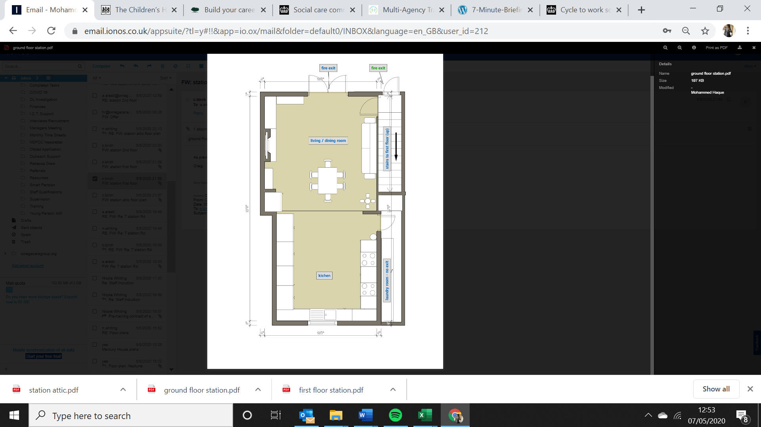

**BASEMENT**

**FIRST FLOOR**

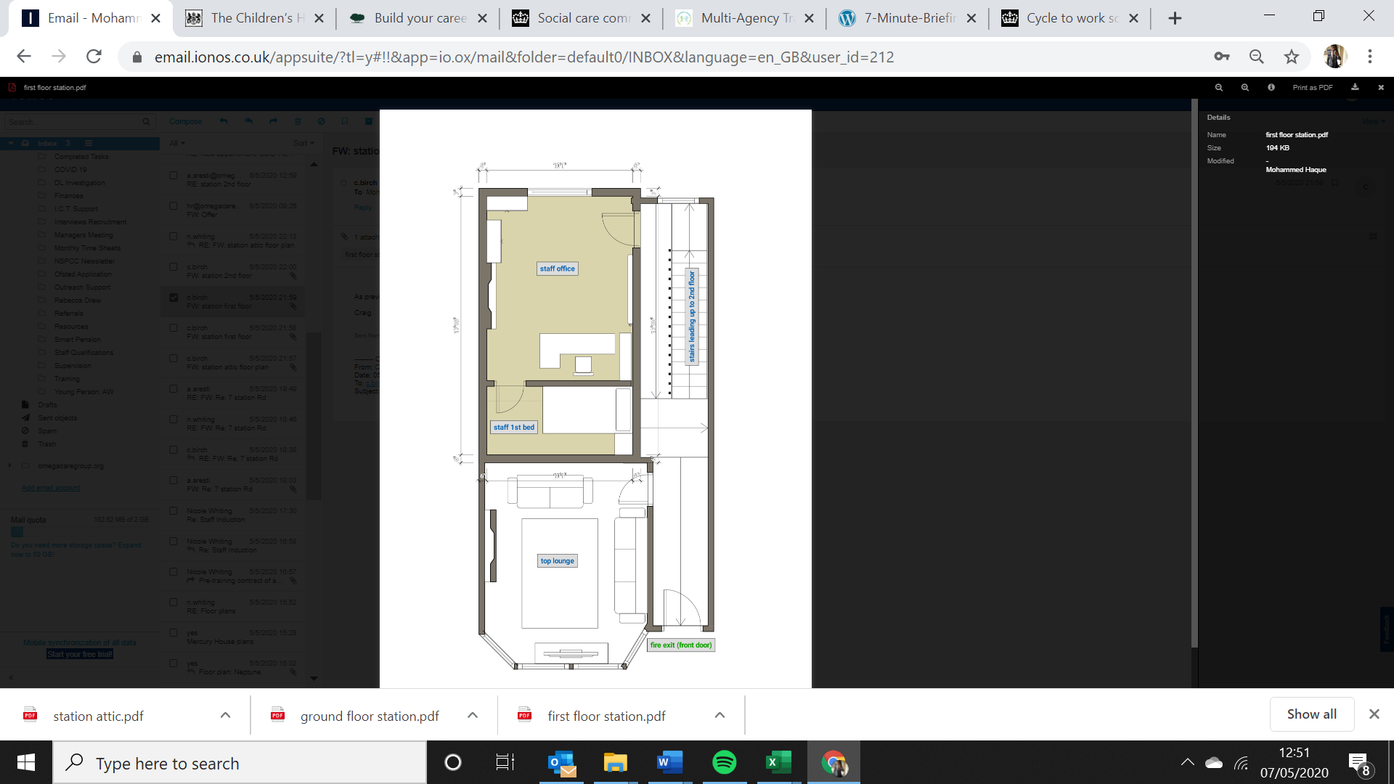

**SECOND FLOOR**

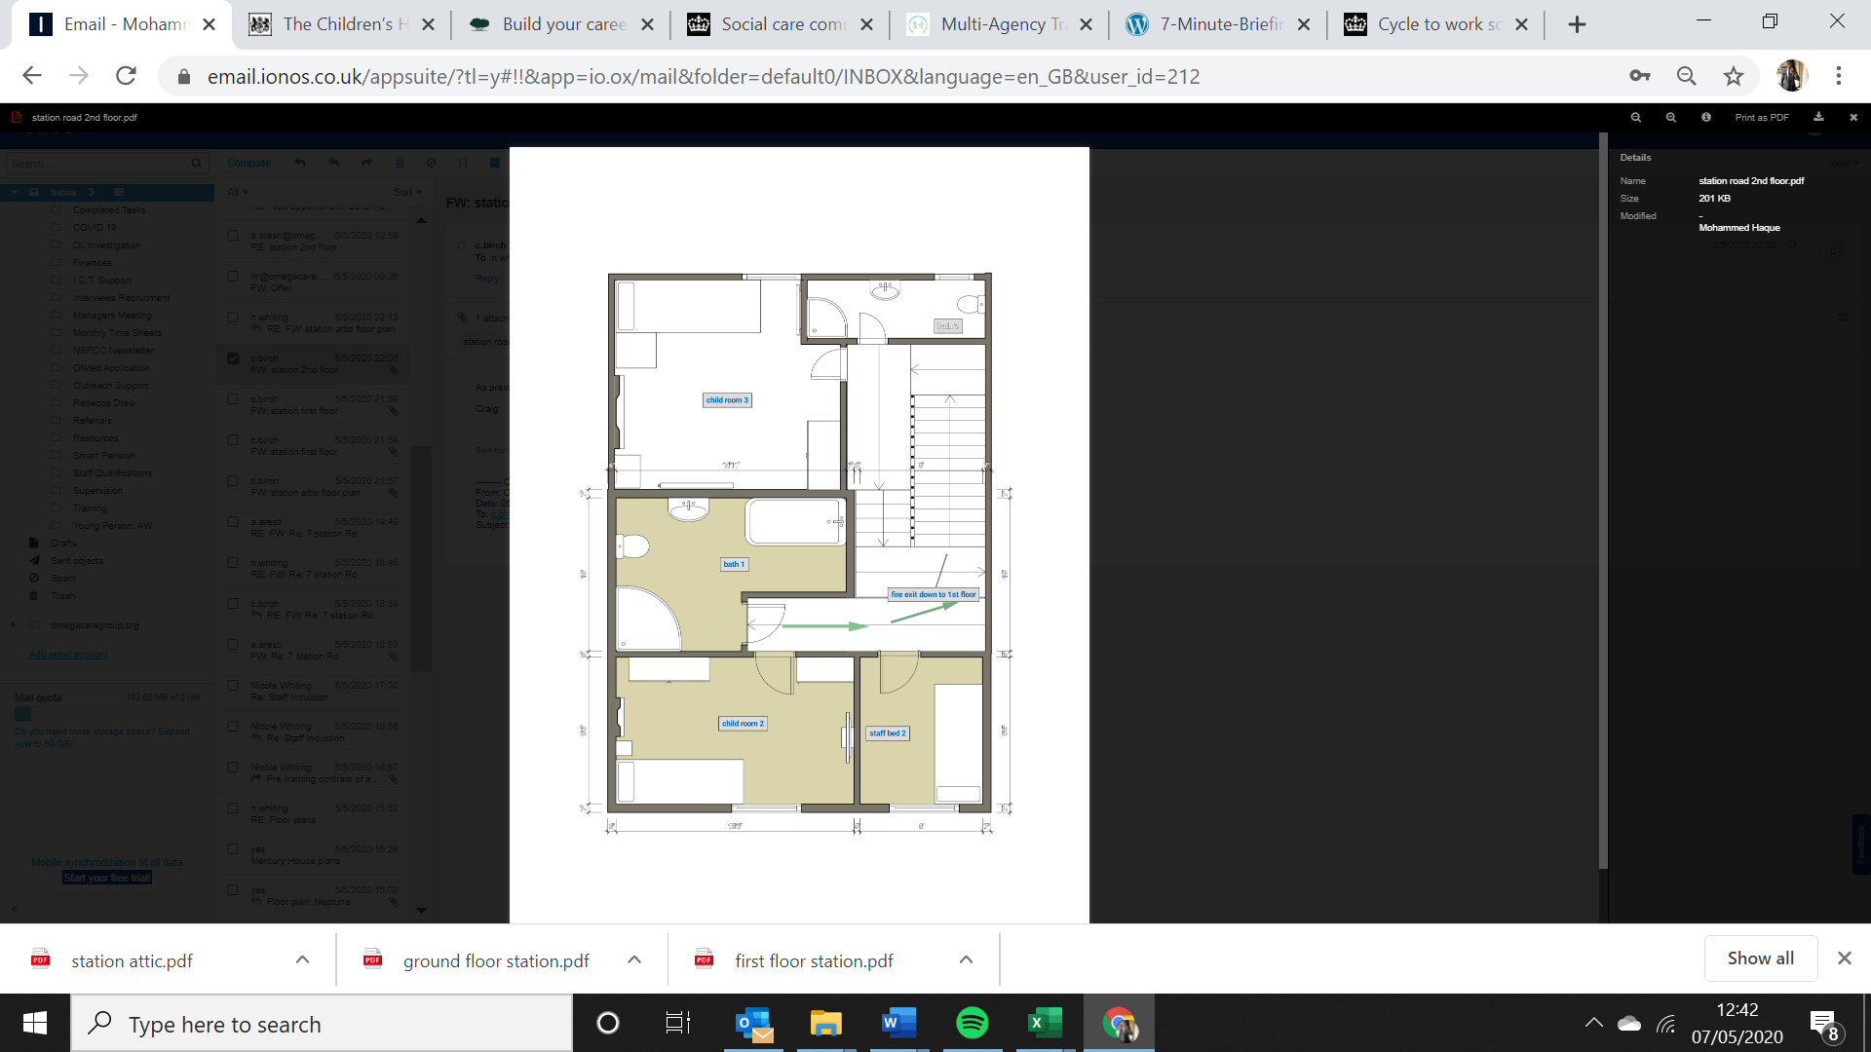

**THIRD FLOOR**

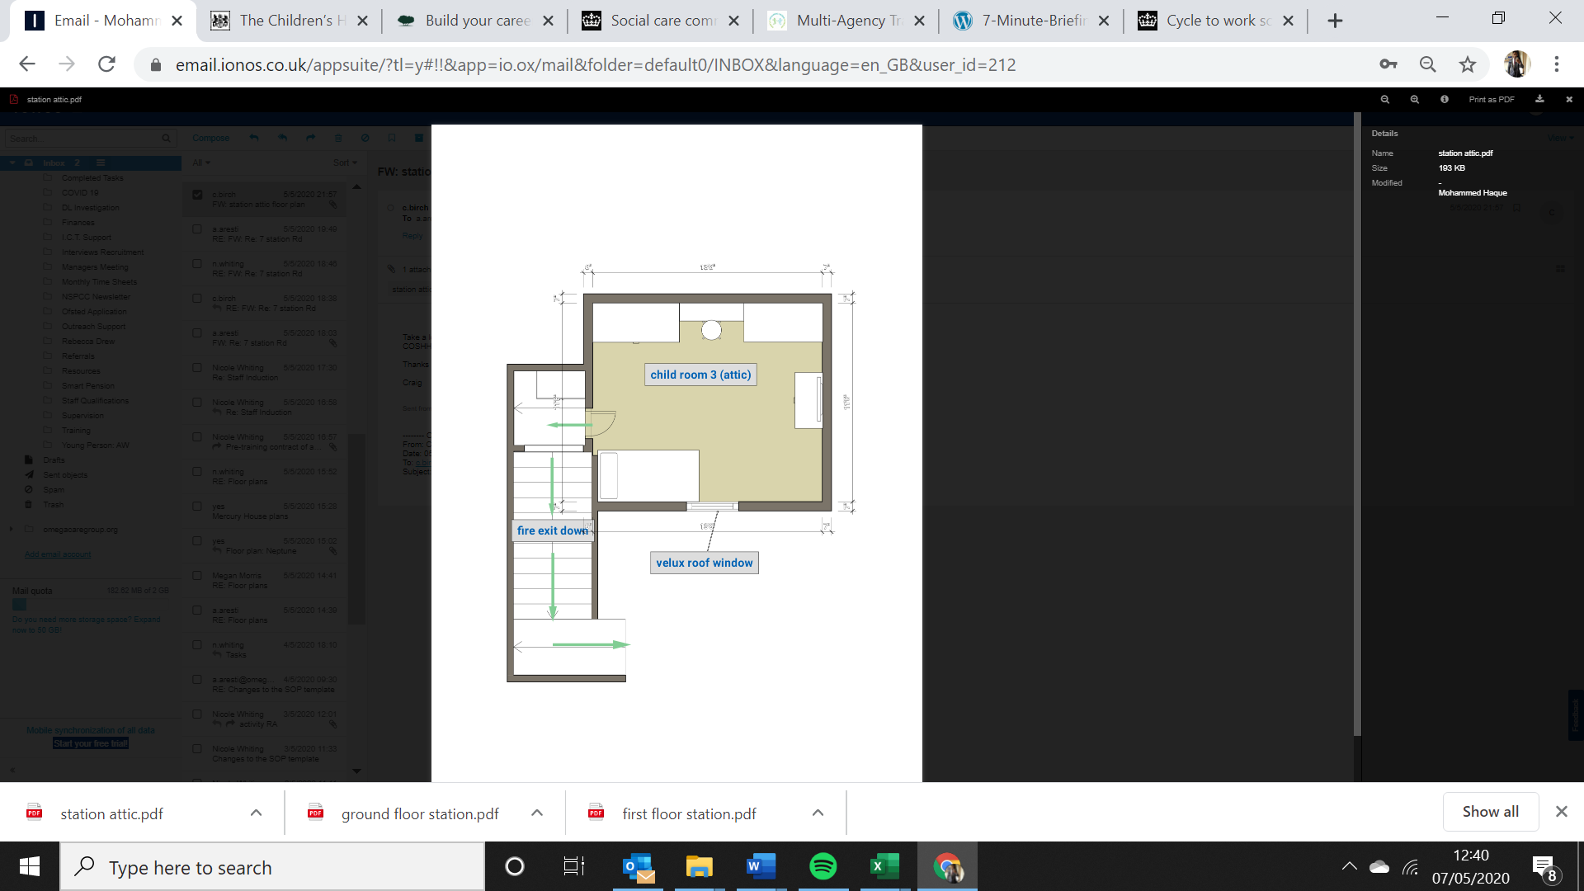

## **Location of the home**

Mercury House is located on Station Road just off Liverpool Road in Prescot, Liverpool L34 5SN. It is a mid-terraced home in a residential road. At the end of the road there is a retail Park (Cables) which has a multitude of shops and small businesses, including beauty bars, fast food / takeaway shops, McDonalds, DIY stores, clothing outlets, Argos and other popular high street stores, a little further down the main road there is a large Tesco (with petrol station and cash point)

There is a bus stop a short walk away that can take you straight into the center of Liverpool in approx. 30 minutes on the 10, 10A. And in the opposite direction the same number buses will take you to St Helens. There is also a train station within a 5-minute walk from the house, also with links to St Helens, Liverpool, Manchester.

## **Supporting cultural, linguistic and religious needs**

Mercury House encourage the child or young person to develop respect for themselves and others. It is the culture within the organisation and home that children and young people of all races are cared for and valued equally and no form of racism (or indeed any kind of prejudice) towards adults or children and young people within or outside the home is acceptable or will be tolerated. It is the role of every staff member to ensure that this culture is welcomed and celebrated.

All religions and belief systems are held in high regard and the home will be proactive in promoting the child and young person’s participation in relative services where appropriate.

|  |  |  |  |
| --- | --- | --- | --- |
| Places of Worship | | | |
| Service | **Address** | **Contact Person / Telephone No. / Email** | **Distance** |
| C of E Church | Saint Pauls Church  17 Ashurst Cl  Saint Helens  WA11 9DN | [01744 453181](https://www.google.com/search?rlz=1C1DIMC_enGB871GB871&sxsrf=ALeKk00D8PabE7jQ53KylqFSCJCk3-FOow:1586795142360&q=Saint+Paul%27s+Church,+17+Ashurst+Cl,+Saint+Helens+WA11+9DN&spell=1&sa=X&ved=2ahUKEwinoKrG6OXoAhWIiVwKHZrmCT0QBSgAegQIFhAn&biw=1280&bih=561) | 6.0 miles |
| RC Church | St Bartholomew's Church  Rainhill  Rainhill  Prescot  L35 6NY | [0151 426 4638](https://www.google.com/search?q=St+Bartholomew%27s+Church%2C+Rainhill%2C+Rainhill%2C+Prescot+L35+6NY&rlz=1C1DIMC_enGB871GB871&oq=St+Bartholomew%27s+Church%2C+Rainhill%2C+Rainhill%2C+Prescot+L35+6NY&aqs=chrome..69i57.462j0j9&sourceid=chrome&ie=UTF-8) | 2.7 miles |
| Methodist Chapel | Queen’s Hall Wigan Methodist Mission Church  46 Market Street  Wigan  WN1 1HX | 01942 244358 | 400 yards |
| Jehovah’s Witness Kingdom Hall | Kingdom Hall of Jehovah’s Witnesses  Oak View  Leyland  PR25 1YN | 01772 453121 | 11 miles |
| Hindu Temple | Shree Swaminarayan Temple  161 Deane Road  Bolton  BL3 5AH | 01204 651934 | 7.2 miles |
| Jewish Synagogue | Whitefield Synagogue  Whitefield Hebrew Congregation  Park Lane  Whitefield  Manchester  M45 7PB | 01617 66372 | 14.9 miles |
| Muslim Mosque | Imran Trust  19 Elton Head Road  St Helens  WA9 5AU | [07856 039289](tel:07856039289) | 3.8 miles |

Any structures and rituals, physical or dietary requirements and clothing will be supported, providing there is no risk of significant harm. The child or young person will also be supported to attend any related events or social groups within this preference. Where special privacy is needed in order to pray during the day, consideration will be given to how best to provide this.

Whilst their own culture will be encouraged, so too will a broad knowledge of alternative cultures through film and music, dance and drama, art and food.

Where a child or young person have been moved from their local area, the staff ensure that they can maintain links to friends and family where appropriate, and where not appropriate, they are educated as to the reasons why. Staff also ensure the promotion of activities that the child or young person took part in prior to their move to ensure opportunities continue and consistency maintained in their life wherever possible.

Mercury will support the child or young person who have individual linguistic needs and will, when necessary, use a range of tailored communication approaches through the use of a communication plan. This may include, for example, visual aids for timetables and activities, documentation in alternative languages etc.

## **Complaints and being heard:**

The complaints process for Mercury House is outlined within the young person’s induction process, this can be tailored to the specific needs of the child, within the Young Persons Guide along with a sample complaints form.

The three-level process, from informal resolution to making an external complaint is accessible and unambiguous in affirming the young person’s unequivocal Right to make a complaint if they are dissatisfied or unhappy with any aspect of their care. The young person will always receive a timely and effective response and be fully supported to access and understand all processes involved.

There are three distinct stages through which a complaint may be progressed. The following is a summary of these stages.

**Stage 1 Local Resolution – Maximum of 10 days**

This stage provides the opportunity for an informal complaint to be resolved locally by the home’s Manager and sent to [ComplaintsCR@Omegagroup.org](mailto:ComplaintsCR@Omegagroup.org) All efforts will be made to resolve complaints immediately within the home being as impartial and unbiased as possible. Nicole will assess the complaint to see ff it merits to be put forwards to stage 2 in line with most recent complaint policy.

**Stage 2 Formal Consideration – Maximum of 10 days**

When the complainant is not satisfied with the outcome at Stage 1, or the complainant feels that the complaint needs to be dealt with formally, then a formal investigation is undertaken by the company’s Service Manager Nicole Whiting. As the Service Manager is currently stepping in as Interim Manager, any complaint regarding Nicole Whiting will be investigated by Tony Mathewson, Quality Assurance Officer.

**Stage 3 Review Panel – Maximum of 10 days**

When the complainant is not satisfied with the outcome at Stage 2, then the matter will be forwarded to the company director Alex Aresti to review the recommendations that are made.

Complaints can also be made to the child or young person’s **placing authority**. Details of how to do this will be available in the home and will be made available to the child or young person on admission.

The Regulatory Authority, **Ofsted**, can be contacted by post at:

Ofsted

Piccadilly

Store Street

Manchester

M1 2WD

Tel: 0300 123 1231

Email: [enquiries@ofsted.gov.uk](mailto:enquiries@ofsted.gov.uk)

Web: <https://contact.ofsted.gov.uk/online-complaints>

**The Children’s Commissioner** can also offer free support, advice and information to anyone in care, leaving care, living away from home or working with children’s services:

**Children’s Commissioner for England** - Annie Longfield

Sanctuary Buildings

20 Great Smith Street

London

SW1P 3BT

Tel: 0800 528 0731

Email: [help.team@childrenscommissioner.gsi.gov.uk](mailto:help.team@childrenscommissioner.gsi.gov.uk)

Web: <https://www.childrenscommissioner.gov.uk/help-at-hand/>

Should there be a complaint about the Registered Manager of the home, the service manager or Responsible Individual, can be contacted on 07804 913141 or alternatively, the child or young person’s social worker.

There are several organisations that can provide an advocacy service. We can support in contacting one of them.

## **Safeguarding policy and behaviour development management policy**

Omega Care Group is fully committed to safeguarding children and young people.

Staff within Mercury House have a portable enhanced disclosure and barring certificate on commencing employment, and this is checked every 3 years. All staff will be subscribed to the online DBS update service.

The following policies and procedures are all in place for the protection of children and young people and are available: -

* Anti- Bullying
* Arrangements for first Aid
* Complaints
* Risk Management
* Digital & E Safety
* Debt Protocol
* Lone Working
* Medication
* Missing from Home
* Behaviour Development Management Policy
* RPI
* Professional Boundaries
* Right to Work
* Safeguarding
* Safer Recruitment
* Whistleblowing
* Data Protection and GDPR
* Disciplinary

It is an expectation that all staff adhere to these policies and procedures to ensure they have the knowledge and skills to identify any cause for concern and are able to deal with disclosures and allegations of abuse. Copies of the guidance and procedure are available on request from the Registered Manager.

The team members are trained and regularly refreshed in the areas of safeguarding and also complete a safeguarding workbook to demonstrate their learning in this area.

It is accepted that staff working within Omega Care Group may be working with children and young people on a daily basis who present with a range of behaviours considered to be concerning. Behaviours of concern should not be seen in isolation, but in the context of the child or young person’s life experiences and learned behaviours. Any approach to support concerning behaviour should be part of holistic practices which are ’child-centred’, understood by all the staff working with the child and applied consistently. The Behaviour Development Management Policy is available at the home in paper-based form with the company’s full policy index.

Staff work closely with local authorities and public services to formulate personalised plans (placement plans, therapeutic plans, behaviour support plans, risk assessments etc.) to protect each child or young person. They will endeavour to:

* Risk assess whether each child or young person is at risk of harm, taking into account information from their statutory care and placement plans
* Make arrangements to reduce the risk of harm to each child or young person taking account of that information
* Protect each child or young person effectively from harm
* Support each child or young person to understand how they can manage their own safety
* Manage relationships between children and young people to protect them from harming each other
* Understand their individual responsibilities and roles in relation to protecting children and young people, including what action to take whenever there is a serious concern about a child or young person’s welfare
* Take effective action whenever there is a serious concern about a child or young person’s welfare, responding appropriately and alerting and seeking to involve relevant persons to manage risks and maintain each child or young person’s safety
* Monitor the physical environment to protect each child or young person from avoidable hazards to health

Staff complete key work sessions surrounding child sexual exploitation, road safety, appropriate relationships, online safety etc. where it is appropriate to meet such individual needs of the child or young person.

Staff are aware of allegations against staff procedures which is stipulated in the Whistleblowing policy. If the alleged abuser is a member of staff, they may be suspended or placed on alternative duties without prejudice until a full investigation has been completed.

The Designated Safeguarding Children’s Officer for the service and home is Nicole Whiting who can be contacted on No. 07554238875

All safeguarding concerns including disclosures and allegations will be forwarded to [SafeguardingCR@omegacare.org](mailto:SafeguardingCR@omegacare.org) to be assessed on severity and establish whether it merits to be shared with the wider system.

The Local Authority Designated Officer (LADO) is Jackie Evans, who can be contacted on No. Jacky Evans – 0151 443 3928 / 07500 765 044 [jacky.evans@knowsley.gov.uk](mailto:jacky.evans@knowsley.gov.uk)

**Knowsley Mash Team (Multi Agency Safeguarding Hub)**

0151 443 2600 / 777 6614 [Knowsleymash@knowsley.gov.uk](mailto:Knowsleymash@knowsley.gov.uk) and [artplacements@knowsley.gov.uk](mailto:artplacements@knowsley.gov.uk) (all admission and discharged need to be shared with the Knowsley Mash Team and Knowsley Placement Team)

**Knowsley Shield Team (Missing and Exploitation)**

Pam Foster

0151 443 3928

**Missing from Home Co-Ordinator**

Chris Miller

0151 447 8816

**School Nurse**

Karen Moss

0151 676 5939

**Knowsley CAHMS**

0151 489 6137

**CAHMS Response Team (out of hours)**

01744627618

**Knowsley Integrated Service – Drugs/Alcohol**

David Davies

0151 482 6291

**Specialist LAC Nurse**

Rebecca Holt

0151 244 3321.

Notification of children new into placements within Knowsley (or moving on), and relevant incidents, should be sent to the LAC Health team via

[5bp-tr.knowsleylachealthteam@nhs.net](mailto:5bp-tr.knowsleylachealthteam@nhs.net)

**SPOC PCSO for Knowsley – Missing Person Liaison Officer**

Becky Davies,

[Rebecca.Davies@merseyside.police.uk](mailto:Rebecca.Davies@merseyside.police.uk)

**Knowsley Virtual School**

Huyton Municipal Building  
Archway Road  
HUYTON  
Merseyside  
L36 9YU

0151 443 3228

[CLAEducationadmin@knowsley.gov.uk](mailto:CLAEducationadmin@knowsley.gov.uk)

**Safeguarding Partnership Training**

<https://www.knowsleyscp.org.uk/multi-agency-training/>

**YOS contact for placement Providers**

Catherine Johnson,

[Catherine.johnson@knowsley.gov.uk](mailto:Catherine.johnson@knowsley.gov.uk)

0151-443-3858

**Safeguarding and Quality Assurance Manager**

Debbie Cashman 0151 443 4786

Sue Walker (Secondment)

2nd Floor,  
Nutgrove Villa,  
Westmorland Road,  
Huyton,  
L36 6GA

**Tel**: 0151 443 5099  
**Email**: [**Sue.Walker@knowsley.gov.uk**](mailto:Sue.Walker@knowsley.gov.uk)

**Group Manager**

Lisa Riley – 0151 443 3374

**Team Managers:**

CP1 – Selina Kent 0151 443 3452  
CP2 – Carla Jones 0151 443 3450  
CP3 – Laura Hardy 0151 443 4568  
CP4 – Karen Fearns 0151 443 3451

Ann Clarkson (Head of Children Looked After)

2nd Floor,  
Nutgrove Villa,  
Westmorland Road,  
Huyton,  
L36 6GA

**Tel**: 0151 443 3375  
**Email**: [**ann.clarkson@knowsley.gov.uk**](mailto:ann.clarkson@knowsley.gov.uk)

**Team managers:**

CLA Team 1 – Natalie Hadwin 0151 443 4235  
CLA Team 2 – Danielle Roberts-Wareing 0151 443 4172  
YPT Manager – Virinder Crawford 0151 443 4054  
Children with Disabilities – Claire Cashmore 0151 443 4273  
Leaving Care Manager – Rachael Burke 0151 443 4117

Ruth France (Head of Service for Children Looked after provision)

2nd Floor,  
Nutgrove Villa,  
Westmorland Road,  
Huyton,  
L36 6GA

**Tel**: 0151 443 2952  
**Email**: [**ruth.france@knowsley.gov.uk**](mailto:ruth.france@knowsley.gov.uk)

Views, Wishes and Feelings Regulation 7

## **Consulting with children and young people**

Mercury House is managed and run, as far as is practically possible, to reflect a nurturing and safe environment. The child or young person is consulted about all aspects of their daily life. Staff at Mercury House endeavour to:

* Seek, consider and, where possible, act upon the child or young person’s wishes and feelings in relation to decisions about their care and welfare
* Regularly seek the child or young person’s feedback, about the quality of the home’s care through resident meetings and feedback forms
* Explain to the child or young person how their wishes and feelings have been considered and give reasons for decisions
* Support the child or young person to express their wishes and feelings
* Explain to the child or young person how their confidentiality will be respected and the circumstances when it may have to be set aside
* Assist the child or young person to prepare for a LAC review and to make their wishes and feelings known for the purposes of a review
* Keep under review and, where appropriate, revise the Children’s Guide, ensuring a revised copy is distributed
* Support the child or young person to understand the content of the Children’s Guide, reports about the home or anything that affects the quality of the care they receive
* Enable the child or young person in our care to provide feedback to, and raise issue with, an appropriate person about the support and services they receive
* Listen to the child or young person and take their views into account when planning and undertaking their care
* Give the child or young person the information, appropriate explanations and choices about daily life in the home and the wider plan for their care
* Having regard to each child’s age and understanding, give an explanation as to how to make a complaint or representations in relation to the home or the care they receive and how any such complaint or representations will be dealt with
* Ensure the child or young person has access to advocacy support to ensure their voice is heard

Consultation with external professionals working with the home can provide opportunities for feedback from the child or young person such as through the Regulation 44 Visitor or Quality Assurance Visits from the placing authorities. Written consent is sought by the child or young person and placing authorities we support to ensure they give permission for any external visitors to inspect and access the records as part of the Independent Visit process.

Child ad young person meetings are encouraged prior to Team Meetings to allow the child or young person to have a say on the agenda.

Moreover, it is our experience that young people will often express their wishes, feelings and views spontaneously. Staff will therefore respond as necessary at the time. In addition to this, key working sessions and regular progress reviews are used to explore and discuss relevant matters and reach agreement on action to be taken if any.

A child or young person will work closely with their key worker on their care plan and are encouraged to discuss what they want for themselves for both the short and long-term future. They discuss how they think they can reach these goals and what they feel they need to do in order to achieve them.

Looked After Reviews are normally chaired by an Independent Reviewing Officer and are designed to ensure that adequate plans are in place to safeguard and promote the overall welfare of the child or young person; and to make recommendations, as necessary, for changes to those plans. Mercury House would expect these to be conducted to the following timeframes:

* An Initial Looked After Review should be conducted within 20 days of the child being Looked After
* The second Looked After Review should be conducted within three months of an Initial Looked After Review
* Subsequent Looked After Reviews should be conducted not more than six months after any previous review

These are maximum timescales; Looked After Reviews can be convened sooner if consideration is being given to ending or changing the child's placement or the urgency of the case determines they should be. The child or young person is encouraged to be actively involved in LAC meetings and supported to express their views, wishes and feelings.

Mercury House expects placing authorities to ensure Care Plans / Pathway Plans are set up at the relevant time, however this will be monitored by the Registered Manager and where appropriate plans requested if not available.

The child or young person can contribute to staff appraisals and supervisions through our 360 approach to staff development. Mercury House will also request feedback from services we work with regarding the level of service the home provides to each child or young person.

3 month quarterly consultations will be completed with young people with a 72 hour response from the management team.

## **Anti-discrimination and families and children’s rights**

There is no legal definition of bullying however, it’s usually defined as behaviour that is:

* repeated

• intended to hurt someone either physically or emotionally

• often aimed at certain groups, e.g. because of race, religion, gender or sexual orientation

It takes many forms and can include:

• physical assault

• teasing

• making threats

• name calling

• cyberbullying - bullying via mobile phone or online (e.g. email, social networks and instant messenger)

The damage inflicted by bullying can be frequently underestimated. It can cause considerable distress to a child or young person, to the extent that it affects their health and development or, at the extreme, causes them significant harm (including self-harm).

We endeavour to promote and safeguard the welfare of the child or young person, and the right of all staff to feel safe in their working environment. It is the responsibility of all staff members to ensure that each individual living or working at Mercury House is treated with respect and is protected from oppression, humiliation and all forms of abuse. Staff will aim to identify a child or young person who is at risk of being bullied and will endeavour to ensure that they are protected from all forms of physical abuse, maltreatment or exploitation, including sexual and racial abuse. The child or young person will be encouraged to recognise their own rights and to understand that rights carry a responsibility to respect the rights of others.

At all times staff will promote anti-oppressive practice both with young people, each other and any other person visiting Mercury House in either a professional or personal capacity.

Education Regulation 8

## **Supporting children and young people with special educational needs**

From 1 September 2014, statements of educational needs have been replaced by Education, Health and Care (EHC) plans. The Virtual School Head (VSH) should ensure that:

* the special educational needs and disability code of practice 0 to 25 years, as it relates to looked after children, is followed; and,
* the child’s statement or EHC plan works in harmony with his or her care plan to tell a coherent and comprehensive story of how the child’s needs are being met.

Professionals should consider how the statement/EHC plan adds to information about how education, health and care needs will be met without the need to unnecessarily duplicate the information that is already part of the child’s care plan. Mercury House staff are mindful that some children may have undiagnosed special needs when they start to be looked after. The Personal Education Plan (PEP) is a record of what needs to happen for looked after children to enable them to fulfil their potential and reflects any existing education plans, such as a statement of special educational needs, Individual Education Plan (IEP) or provision mapping. The PEP should reflect the importance of a personalised approach to learning which secures good basic skills, stretches aspirations and builds life chances.

## **Education curriculum and the arrangements for education**

Mercury House will seek for all children and young people to enrolled and engaged with a mainstream schools, alternative education provisions, temporary in house education until a an education provision is allocated or training employment scheme.

## **Promoting educational achievement**

When a child becomes looked after, local authority will arrange a suitable placement. In doing so, the child’s allocated social worker should do everything possible to minimise disruption to the child’s education, whatever the child’s age but particularly at key stage 4, and this should involve the Virtual School Head (VSH).

If it is not possible to maintain the child’s existing education placement, the child’s new education placement should be arranged in consultation with the VSH at the same time as the care placement. The VSH has primary responsibility for ensuring that there is suitable education in place for all children looked after by the local authority. Their views should be given appropriate weight as part of decisions on placement moves. There should also be appropriate consultation with the VSH in another local authority where out-of-authority placements are planned and made.

In arranging a school placement, the child’s social worker (working with the VSH and other local authority staff, where appropriate) should seek a school or other education setting that is best suited to the child’s needs.

The following principles should apply:

* educational provision should mean a full-time place
* schools judged by Ofsted to be ‘good’ or ‘outstanding’ should be prioritised for looked after children in need of a new school. Unless there are exceptional evidence-based reasons, looked after children should never be placed in a school judged by Ofsted to be ‘inadequate’
* the choice of the education setting should be based on what any good parent would want for their child. It should be based on evidence that the setting can meet the educational needs of the child and help them make the maximum progress
* the child’s wishes and feelings should be considered and the suitability

We believe the educational needs of ‘looked after’ children and young people should wherever possible be met within mainstream education services and we strive for the child or young person in our care to access an appropriate and sustainable school placement.

For the child or young person who has previously experienced failure in the education system arising from social and emotional difficulties which make it difficult for them to function in the mainstream education environment we recognise that specialist full time education is necessary.

In these circumstances, staff will work closely with educational professionals to secure an alternative provision such as a Pupil Referral Unit or for an interim period, where a child or young person is excluded, an individual education programme will be devised by staff in conjunction with the VSH.

A child or young person on reduced school timetables will be expected to continue to participate in individual education programmes within full time school hours unless otherwise agreed in individual care plans. Family contact does not normally form part of the school day unless agreed in the child or young person’s care plan.

Where the child or young person is only receiving part time education, staff will work closely with the school to increase the timetable to full time hours if possible or seek extra home tuition during unfilled school hours.

School attendance will be checked daily with local schools and recorded by staff. The child or young person may work towards rewards for regular and improved school attendance. Staff will support attendance through assisting with travel to and from school.

Staff will encourage the child or young person to complete homework on their return from school, liaising closely with school around homework diaries or any online recording system utilised by the school and individual education programmes.

Mercury House, in collaboration with the child or young person’s social worker, will also provide school uniform and education equipment and supplies, as well as funding for school meals, school trips and excursions.

Staff will attend PEP’s, parents’ evenings and other school meetings where agreed in the care plan and support the child or young person in attending after school clubs and appropriate extracurricular clubs.

Each young person’s file will contain a copy of their PEP, which sets out a record of educational achievements, needs and aspirations and will include the contact details of the VSH for the authority that looks after the child. It will also contain any record of educational history and any statement of special educational needs / EHC plan.

Enjoyment and Achievement Regulation 9

## **Social outcomes**

We aim to provide a range of experiences, opportunities and activities to meet individual physical, emotional, social, behavioural, psychological and educational needs of the child or young person in placement. Birthdays, name days, cultural and religious festivals are also celebrated where appropriate. The child or young person is encouraged to plan their own weekly activity programme with support and guidance from staff. Where required support staff will research activities requested by the child or young person and organise such activities if deemed appropriate and subject to risk assessment.

The child or young person will also have the opportunity to select newspapers, magazines, books, music and games subject to suitability on a weekly and monthly basis. We aim to provide a range of experiences, opportunities and activities to meet individual physical, emotional, social, behavioural, psychological and educational needs.

Trips out to events for enjoyment or interest are promoted and encouraged and are organised by staff and child or young person as appropriate. Mercury is close to the following amenities for local activities and socialising for young people: -

|  |  |  |  |
| --- | --- | --- | --- |
| Leisure and Activities | | | |
| Service | **Address** | **Contact Person / Telephone No. / Email** | **Distance** |
| Park | Eaton Street Park  Prescot  L34 6HH |  | 0.8 miles |
| Leisure Centre | Broadway Leisure Centre  Broadway  Grange Park  St Helens  WA10 3RW | 01744 738178 | 2.4 miles |
| Youth Centre | Prescot Community & Youth Centre  Bryer Road  Prescot  L35 5DW | 0151 433 4541 | 0.5 miles |
| Bowling | Superbowl  Linkway West  A58  St Helens  WA10 1QA | 01744 747 975 | 2.8 miles |
| Cinema | Cineworld  Chalon Way W  St Helen  WA10 1BF | 0330 333 4444 | 3.0 miles |
| Horse Riding | Lodge Riding Centre  Tarbuck  Dacre’s Bridge Lane  Liverpool  Prescot  L35 1QZ | 0151 489 8886 | 2.2 miles |
| Singing  Music | Village Music School  2-4 Victoria St  Rainhill  Prescot  L35 0LB | 0151 431 1333 | 1.7 miles |
| Child in Care Council | NYAS  Tower House  1 Tower Road  Birkenhead  CH41 1FF | 0151 649 8700 | 9.3 miles |

The young person is also encouraged to join the local youth club and sporting groups in and around Prescot area.

Mercury House understands the importance of play and social normalisation; therefore, we encourage and support the child or young person to make and sustain friendships with young people outside of the home. Mercury staff welcome friends for dinner as well as organised ‘play dates’ where appropriate. Staff have a good understanding of the range of influences that friendships can have and encourage those with a positive impact and discourage those with a negative impact.

Activities need to be carefully planned to balance realistically with those other children and young people would receive in a family home whilst ensuring opportunity to experiences of childhood that may otherwise have been missed.

Health and Wellbeing Regulation 10

## **Health outcomes**

Individual health care needs are identified on admission and arrangements for continuity of medical care are recorded in the Placement Plan. Confidential health records maintained for each child or young person include details of any health problems or illnesses, prescribed treatments and the administration of medication. The child or young person is supported to remain with their current doctor, dental practice and opticians but if the distance is too far, we register them with the local doctors at Prescot Medical centre, the dentists at Prescot house dental surgery, and the opticians at Vision Express Prescot within 7 days of admission.

The local LAC nurse for Mercury House is based in Knowsley who often visits the home to provide health care and information for the child or young person. They can be accessed by contacting

Manor Farm Primary Care Resource Centre  
Manor Farm Road

Huyton  
L36 0UB   
Tel: 0151 290 4990

##### Email: [5bp-tr.manorfarm0-19@nhs.net](mailto:5bp-tr.manorfarm0-19@nhs.net)

Staff are also aware of the NHS helpline (111) that they can be used for additional advice and support if needed.

Staff monitor any changes in the child or young person’s health and arrange appropriate care or treatment after obtaining, if appropriate, the child’s consent.

## **Training**

Staff will complete a range of training modules to promote health & wellbeing including adverse childhood experiences, epilepsy, and diabetes training.

## **Medication**

All medicines are kept in a locked medicines cabinet which the shift leader is responsible for, unless the child or young person is deemed competent and risk assessed to self-administer their own medicines, in which case a lockable cabinet will be provided for the child or young person to have in their room. All core staff are trained in the Safe Administration of Medicines.

## **Exercise**

Every effort is made to ensure the child or young person can maintain their interests and hobbies and are encouraged to try out new opportunities they may not have experienced previously. The child or young person will be encouraged to take regular exercise and to positively engage with chosen activities. Staff will actively promote and support the child or young person when engaging in such activities. Access to sport in the community, horse riding, outward bound pursuits, drama and dance groups, army cadets, swimming, tennis etc can be arranged. The child or young person is encouraged to join the local gym where they will have access to gym equipment/ the swimming pool / exercise classes. The home uses an electronic recording system that enable patterns and trends to be identified very easily. This ensures that the child’s health is closely monitored and progressed in appropriate timescales.

## **Diet**

The child or young person at Mercury House is encouraged to eat a well-balanced diet. They are involved in the preparation of menus on a weekly basis, assist with the weekly shop and participate in the preparation and cooking of food. This also allows for the child or young person to develop independence skills. The child or young person in our care is also encouraged to try new cuisines and all personal tastes are accommodated for, subject to health monitoring and individual needs.

Where necessary, Mercury House will work in partnership with other agencies including dieticians, and the LAC Nurse in order to meet the individual needs of the child or young person.

## **Personal Hygiene**

The child or young person will be provided with guidance, advice and support on health and personal care issues appropriate to their needs and wishes. They choose their own toiletries and personal hygiene products and regularly go shopping with the staff team. Where appropriate, the child or young person will have the opportunity to purchase these items whilst on independence time subject to risk assessment. Staff discreetly monitor standards of personal hygiene and provide guidance and encouragement as necessary. Any specific concerns are raised in the young person’s placement plan with clear strategies on how to best manage this, allowing the staff team to follow and understand the appropriate support to be used.

## **Smoking**

It is against the law to smoke in Mercury House. Members of staff and visitors are not allowed to smoke in front of the child or young person; they are required to be discreet when leaving the building and site to go for a cigarette. Guidance is given to the child or young person on related health risks and support is offered to the child or young person wishing to give up the habit.

We do not give a child or young person under the age of 18 years permission to smoke.

Young people are actively discouraged from smoking.

It has been agreed that a young person who does smoke can smoke cigarettes in the back garden to avoid congregating in the road and disturbing neighbours. This is not a social event and the child or young person therefore cannot smoke in the presence of any other young person or adult.

The designated smoking area of the back garden is not to be used by an adult in any circumstances.

## **Alcohol and Drug Misuse**

The consumption of alcohol and the use of drugs is not permitted within any part of the home. Staff provide advice and guidance on the risks associated with drug and alcohol misuse in order to educate the child or young person in placement of the potential effects both can have upon their health. If specific concerns are identified a referral would be made to the relevant local area support services.

## **Sexual Health**

Levels of awareness and risk are assessed on arrival by information supplied by social care and agencies involved in the care of the child or young person. Advice and support is available from staff through key work sessions. If specific concerns are identified a referral would be made to the appropriate service, these include local GUM clinics and family planning centres.

## **Health Education**

Mercury House staff are required to promote a healthy lifestyle and act as a positive role model. Access to specialised guidance and support is arranged as necessary and key workers will routinely focus on health issues such as sexual health, sex education, family planning, and alcohol and substance misuse information, etc. during planned key work sessions. Staff will actively promote all aspects of healthy living by working alongside professionals to ensure that the child or young person in our care are supported and informed surrounding decisions that are made.

Staff will support each child or young person to achieve personalised objectives for their health and well-being as recorded in their placement plan / health plan. The child or young person will be helped to understand and make informed choices about their health and well-being.

## **Therapy**

Mercury house adopts a recovery focus environment which aims to help people with mental illnesses and distress to look beyond mere survival and existence. It encourages them to move forward and set new goals. It supports the view that they should get on with their lives, do things and develop relationships that give their lives meaning.

Staff will useu**nconditional positive regard which refers to accepting and supporting another exactly as they are, without evaluating or judging them.**

Also methods such as Signs of Safety is a strengths-based safety-organised approach to child safeguarding work which expands the investigation of risk to encompass strengths and signs of safety to make an overall judgement of safety using a safety scale.

The home provides virtual and non-virtual literature through the NHS and other services like Barnardo’s or Mind that will always continuously support our young people to develop a coping strategy and provide that on hand support. NHS approved apps will be allocated upon request of the child’s needs.

Mercury House will promote to work with organisations that will support young people’s in managing their mental health effectively. CAMHS and other organisation will be utilised in the best interest of the child liaising with all health professionals involved in the child’s life.

Staff will use reflective practice to evaluate good practice and one’s actions is continually being reviewed and improved.

Trauma Informed Training and Positive Behaviour Training will be provided to all new staff at Mercury Houses part of their induction on recognizing emotional behavioural difficulties via bio physio social model enabling staff to understand trauma related behaviours.

As part of the staff’s development continuous personal development will be paramount to ensure effective practice is maintained at all time for the best interest of the staff and young people.

Positive Relationships Regulation 11

## **Promoting contact between children, their families and friends**

We actively encourage and support contact unless directed otherwise from the placing authority or court.

We will facilitate contact in accordance with the written agreement and seek clarity of any arrangements for permitted or prohibited contacts. We welcome contact at the home and visitors will be offered the opportunity to share meals and refreshments. The child or young person and their visitors will be shown to a quiet space to talk in private, dependent upon the levels of supervision required.

Before visitors can gain access to Mercury House, staff will ensure that they have seen proof of identification. If the visitor is unannounced or is unable to provide identification, then entry will be refused. All visitors will be asked to sign the visitor’s book and must participate in Covid-19 Procedures. Mercury House will support and facilitate phone contact, mail contact or electronic contact, providing that this has been agreed with placing authorities.

The child or young person is encouraged to make friends locally as well as retain friendships from previous placements, their education provision or activity in the community. These friends will be welcome to visit Mercury House in consultation with staff, and the child or young person from Mercury is able to visit their friends if invited and with the agreement from staff.

All contacts are recorded on the electronic recording system and filed in the child’s or young person’s file. Any variation in contact arrangements will be made in full consultation with the placing authority. If it is more appropriate, staff will support contact at a venue away from the home and can provide supervision of the child or young person throughout.

We will support the child or young person as appropriate before, during and after contact, as this can be a very challenging time for them emotionally. We recognise the impact of attachment related issues and staff at Mercury House ensures that there is good communication between parents and the home and the young person and the home on how the contact went. Mercury House is also able to offer support in difficult situations where contact is too risky or unable to take place in their home, by arranging contact within the local area or at a half-way point between the two areas.

For the child or young person who does not have contact, the home will ensure that they have access to an independent visitor. All appropriate checks will be made and agreements from the local authority gained.

Protection of Children Regulation 12

## **Approach to monitoring and surveillance**

The house has a domestic alarm system which is set when the home is empty. The home does not have any surveillance system installed as Omega Care Group’s approach is to keep Mercury House as homely as possible. Any surveillance system and intruder alarms installed in the near future will be to safeguard children and young people which will be discussed with Ofsted and the children and young people’s social worker in line with a written policy to ensure Ofsted guidance is followed and residents human rights is upheld.

## **Behaviour Management Plan**

A Behaviour Management Plan is a document created to help understand and manage behaviour in children and young peoples who have learning disabilities and display behaviour that others find concerning.

A Behaviour Management Plan provides carers with a step by step guide to making sure the person not only has a great quality of life but also enables the staff team are embedding the relevant primary, secondary and tertiary responses to managing behaviours of concern.

A good behaviour support plan is based on the results of a functional assessment and uses Positive Behaviour Support (PBS) approaches. The plan contains a range of strategies which not only focus on the challenging behaviour(s) but also include ways to ensure the person has access to things that are important to them.

The strategies used are referred to as **Proactive Strategies** and **Reactive Strategies**.

**Proactive strategies** are intended to make sure the young person has got what they need and want on a day to day basis and also includes ways to teach the person appropriate communication and life skills enabling to manage their own behaviours effectively.

**Reactive strategies** are designed to keep the person and those around them safe from harm. They provide a way to react quickly in a situation where the person is distressed or anxious and more likely to display challenging behaviour.

A good behaviour support plan has more Proactive strategies than Reactive ones. This helps to ensure that the focus of the plan is not just on the challenging behaviour but provides ways to support the person to have a good life, enabling the person to learn better, more effective ways of getting what they need. This will be in-line with the company’s Behaviour Development Management policy.

## **Sanctions or Consequences**

Sanctions are not punishment but are strategies designed to help a child or young person. Sanctions may only be imposed as a last resort with the intention of encouraging acceptable behaviour or acting as a disincentive for unacceptable behaviour.

Sanctions should be an effective tool and any review must take into account effectiveness of the sanction imposed; if proven ineffective, then other alternative strategies must be applied.

The following sanctions may be imposed, as a negative consequence for unacceptable behaviour:

a. Confiscation or withdrawal of a telephone or mobile phone in order to protect a child or another person from harm, injury or to protect property from being damaged.

b. Restriction on sending or receiving letters or other correspondence (including the use of electronic or internet correspondence) in order to protect a child or another person from harm, injury or to protect property from being damaged.

c. Reparation, involving the child doing something to put right the wrong they have done; e.g.: repairing damage or returning stolen property;

d. Restitution, involving the child paying for all or part of damage caused or the replacement of misappropriated monies or goods. No more than two thirds of a child's pocket money may be taken in these circumstances if the payment is small and withdrawn in a single weekly amount. Larger amounts may be paid in restitution but must be of a fixed amount with a clear start and end period. If the damage is serious or the size of payment particularly large then the child's Social Worker should be informed of the matter;

e. Curtailment of leisure activities, involving a child being prevented from participating in such activities;

f. Additional chores, involving a child undertaking additional chores over and above those they would normally be expected to do;

g. Early bedtimes, by up to half an hour or as agreed with the child's Social Worker;

h. Removal of equipment, for example the use of a TV or video/DVD player;

i. Loss of privileges, for example the withdrawal of the privilege of staying up late;

j. Redduction of pocket money for short periods.

Before any sanction is imposed staff must be satisfied of the following:

* That the child was capable of behaving acceptably and understands what was required of him/her
* Other encouraging and rewarding strategies have not worked or would not work in the circumstances
* The sanction imposed is relevant, fair and must last no longer than is absolutely necessary
* There is a view that the sanction may encourage acceptable behaviour or act as a disincentive

## **Room Search**

Bedrooms should not be generally entered without the child’s permission; room searches should generally not take place unless the child has been informed or permission given. It may be appropriate to conduct an immediate search of a child or a child's belongings, including the searching of a child's bedroom, if there is reasonable cause to believe that the child has concealed weapons, illegal drugs or other items, which may place the child or others at risk of injury. The decision to search a young person or young person's room may only be made by staff after they have consulted with the most senior member of staff on duty. The only exception to this is where the situation is so critical that the search demands an immediate response. The Registered Manager will review every room search that takes place and make comment and / or recommendations as the case may be. In any instance where a room search has taken place, social workers will be sent a full report within 24 hours, usually via e-mail. Senior managers will review all logs on a monthly basis.

## **Safeguarding:**

Mercury House recognises that ensuring the safety and well-being of the young person is paramount. To support this, the setting operates within a comprehensive set of robust and accessible policies. These include:

* Child Protection and Safeguarding (including self-harm).
* Anti-Bullying (Including peer)
* Safer Recruitment
* Behavioural Development Management
* Restrictive Physical Intervention
* Professional Boundaries
* Digital and e-safety
* Risk Management (young people)
* Substance and alcohol use
* Whistleblowing

These are supported by Health and safety, Fire Safety and Risk Assessment and Management Policies.

All staff are recruited through the Omega Care Group Safer Recruitment Process overseen by Service Manager and Responsible Individual. All individuals involved in recruitment hold a certificate in safer recruitment.

Induction training for all staff includes Child protection and Safeguarding, Self-Harm, CSE and CE, Digital and e-safety, Professional Boundaries, Positive Behavioural Support and recording and reporting processes.

All staff are required to demonstrate their understanding of their role and responsibility in safeguarding and in promoting the well-being of young people.

The Registered Manager of the setting is responsible for reporting all serious concerns and incidents/accidents (supported by the Omega Care Designated Safeguarding Officer), and for the management of allegations, including liaison with the Local Authority Designated Officer.

Hard copies of the Safeguarding Policy can be accessed via the office in Mercury House. Copies are also available digital from the house and Omega’s head office.

## **Managing Risk-children and young people:**

The setting undertakes comprehensive Risk Management processes which actively encourages input from young people in identifying triggers and effective responses. These are reviewed weekly or immediately post any incident, and any additional safeguards identified are then implemented. There are effective lines of communication in place with safeguarding partners, multi-agency panels (re: CSE and CE) and the Missing From Care/Home co-ordinator for Merseyside Police (Cheshire).

Staying safe is addressed within each young person’s induction and forms a substantive element of the ILP. It is further promoted through Keywork sessions and informal discussion.

## **Supporting Positive Behaviours: (reference: Behavioural Development Policy and Restrictive Physical Intervention Policy)**

We believe that meaningful, trust based positive relationships between young people and staff are central to the delivery of care and effective support. Mercury House will provide a secure base for young people, promoting a sense of safety, and deliver a consistent and holistic service using a whole team approach. All young people have the right to an emotionally and physically safe home environment.

There will be clear expectations of behaviour and boundaries, as negotiated with the individual young person through a behavioural agreement. Appropriate levels of support will be put in place to maintain consistency and stability and promote autonomy and the development of positive choices. The behavioural agreement will form an essential element of the young person’s induction and use person centred approaches to identify steps and outcomes. The agreement includes both pro and re active strategies to promote and support self-regulatory behaviour and address those behaviours which may challenge.

Following a holistic approach, staff will promote the development of positive coping strategies and ensure the absolute minimisation of the use of restrictive/coercive practice. This approach will be supported by validation, positive reinforcement, praise and encouragement and is supportive of the young person’s strengths.

Staff will work with the young person to identify motivation and the response to both positive and maladaptive behaviours. Aggressive or destructive behaviours will be addressed in a consistent and coherent manner using a Restorative Approach. This supports the young person to reflect on the event and of the impact of the behaviours displayed on others, to understand and empathise with how other people felt and to negotiate what happens next.

At Mercury House, we will try where possible not to use sanctions and therefore only utilise the sanction of pocket money deduction in relation to property damage or theft and is only utilised once all other relevant restorative measures have been unresponsive.

The setting operates within a framework of negotiation, facilitation and de-escalation. Staff receive training in mental wellbeing and support needs, facilitation and de-escalation, and restorative practice This is delivered through the Service Manager, who also provides oversight and on-going support. The aim of the approach is to support the development of the individual young person’s resilience and self-regulatory and self-management abilities.

Children and Young People incident forms and log of preventive measures will be also review monthly by Senior managers.

## **Our Approach to Restrictive Physical Intervention (RPI)**

Restrictive Physical intervention should always be an action of last resort and undertaken solely to maintain the safety of young people, staff member or other individual. The aim of the setting is to minimise any use of restrictive or coercive practice. Staff emphasis is on supporting and empowering positive behaviour strategies, including:

* Prevention
* De-escalation
* Co-identification
* Active listening
* Validation
* Re-direction
* Reflection and using the learning
* Support strategies

Should a child young person’s behaviour reach a level at which they or others are at immediate risk of physical hurt staff may have to physically intervene to ensure all concerned stay safe. Under Duty of Care, staff may be considered negligent if they undertake no action and this results in an individual being hurt. All staff receive training in physical intervention techniques and will use only the minimum amount of force necessary and for the absolute minimum length of time required. Staff should ensure at all times, that the dignity of the young person is respected and that no action undertaken could be misinterpreted.

All incidents involving physical intervention will be recorded, monitored and assessed. Staff and young people involved will be debriefed and behaviour management plans and risk assessments updated. Young people will be offered access to medical support post event and should they refuse, the offer repeated several hours later. All information will be accurately recorded, and behavioural formulations completed.

All Children and Young People will be given the opportunity to read records of incidents and will be encouraged to complete their own record in which captures how they felt.

The staff team use negotiation and restorative practice to address and resolve issues.

We are committed to minimising the use of RPI. We have taken a pledge and are an active member of the Restraint Reduction Policy. Our Restraint Minimisation Policy and Behaviour Development Policy demonstrates our commitment to reducing the need the RPI.

All staff working within Omega Care Group Children Residential will be trained in National Federation Of Personal Safety (NFPS) and will be soon transition to Protecting Rights in a Caring Environment (PRICE) by November 2020 in light of changes to guidance.

## **Missing Child Policy: (Reference: Policy document)**

The PAN Merseyside Safeguarding Partners Children’s Board Missing ChildrenProcedures provide the framework for children and young people missing from home and care. The setting has established contacts within Merseyside Police Missing coordinators.

Episodes of missing reflect the vulnerabilities and insecurities of the individual young person and need to be addressed and the necessary support put in place. Young people who go missing may be at risk through a wide range of factors. Young people’s Risk management plan and missing from care procedure should accurately reflect all known risk factors and vulnerabilities and form part of the reporting process to Merseyside Police, alongside all other relevant information.

If a member of staff has good reason to believe that a child or young person is likely to harm themselves or another by going missing, they are expected to take reasonable measures to prevent this.

On their return home from a missing episode the young person is welcomed back. Staff will explore the episode sensitively and constructively.

Detailed records will be maintained of each missing episode and reviewed regularly.

Omega Care Group will advocate for all return home interviews to be conducted by an independent person in a timely manner (72 Hours).

## **Anti-Bullying: (Reference: Anti-Bullying Policy)**

Mercury House acknowledges bullying to be a safeguarding issue. The setting operates a zero-tolerance approach to bullying, this is supported by clear protocols to address behaviours, support the person experiencing bullying and move towards resolution and the positive recognition and valuing of difference.

## **Care Planning:**

Children and Young people would normally be 10 to 17 years of age.

We would anticipate young people to present a complex range of emotional needs which may be reflected in their presenting behaviours. They may also have a mental health diagnosis.

Admissions will normally be planned, with a time scale enabling progression through an introductory process and familiarising the young person with the layout, the staff team and the expectations and boundaries within the setting. The child and young person’s needs will be reflected within this process along with the needs of any other young person resident. This will provide a more effective transition for the young person to enter the setting.

A Care plan for the young person will be drawn up pre-admission. This will form the starting point for regular care planning meetings and the identification of outcomes.

Placements may be requested though Omega Care Group, where they will be addressed by the Registered Manager, this will be followed by a meeting with Social care and the undertaking of a matching process.

The placement should be reviewed within 72 hours with an emphasis on long term planning.

Care plans should be formally reviewed on a regular basis. Reviews should be chaired by an IRO and attended by parents/carers (if appropriate), social worker. Other professionals and others of significance to the young person.

The young person will be actively encouraged to attend and to express their views and wishes, this will be supported by the IRO. The young person and parents/carers will be invited to submit material in writing.

The meeting will be minute and copies made available to all those attending, including the young person.

The care team will meet on a regular, more frequent basis to share information and insight, and to monitor and ensure progression towards positive outcomes.

End of Placement-effective processes should enable the child or young person to move onto their new environment in a planned and positive manner. However, ongoing risk assessments may dictate that the service for an individual young person is not sustainable and with appropriate agreement the service would therefore be withdrawn. There is recognition of the timescales involved in sourcing the required provision.

## **Care and Control**

Through a multi-disciplinary approach, the provision of a warm caring, nurturing environment and the maintenance of firm and consistent boundaries, we encourage the child or young person to develop the positive relationships that will allow them to gain a sense of personal worth within a nurturing environment. These positive relationships are the predominate means by which behavioural boundaries are maintained and issues of control are dealt with.

The behavioural boundaries set are both appropriate and realistic. If the child or young person does not co-operate, a reminder will be given. If this fails, advice to take time out and calm down may be given. Staff are trained in de-escalation and diversion techniques and are aware that physical intervention is to be used only as a last resort.

Leadership and Management Regulation 13

## **Registered Provider, Responsible Individual, Service Manager and Registered Manager’s contact details**

The Responsible Body is:

Omega Care Group

Golf Centre

C/O

Caldway Dr

Liverpool

L27 0YB

[0151 487 0055](https://www.google.com/search?q=omega+care+group&rlz=1C1DIMC_enGB871GB871&oq=omega+ca&aqs=chrome.1.69i57j69i59j35i39j0l5.5905j0j4&sourceid=chrome&ie=UTF-8)

**The Responsible Individual of the service is:**

Mr Alex Aresti

Manager Director

Tel: 07920048141

Email: [A.Aresti@omegacaregroup.org](mailto:A.Aresti@omegacaregroup.org)

**Managing Director & Responsible Individual**

Alex formed Omega Care Group in October 2015 following several years’ experience as a Director with an innovative company delivering effective young person-centred leaving care provision.  His career before Omega Care Group consisted of working with some of the most complex Children and Young People in the country, in environments such as Secure Children’s Homes and provisions supporting Children displaying Sexually Harmful Behaviour. Alex also spent 2 years with Knowsley Children’s Social Care where he sat on their Fostering Panel on a voluntary basis and as a care leaver, he volunteered in local Community Centres and Youth Play Schemes.

Alex has positive engagement at all levels of Omega Care Group’s work, and actively shapes the ethos and working practises of the organisation.  His values are rooted in his personal life experiences as a care leaver. Alex spent 6 years in the care of the Knowsley Local Authority in various settings from Foster Care to Residential Children’s Homes.

Alex attained QCF Level 5 Diploma in Leadership and Management for Residential Childcare, Level 3 Diploma for the Children and Young People's Workforce and has also attended various training courses to ensure continuous, professional development.

As Responsible Individual, Alex will attend the provision at a minimal three-monthly period.

**Service Manager – Interim Manager**

Nicole joined Omega Care Group in October 2018 with a vast amount of knowledge of mental health and behaviour support, something which is extremely important to Omega Care Group. Nicole is developing in a unique role as Practice development Lead within the company, delivering quality training to the Specialist and Children’s staff team to support the facilitation of the PARTNERSHIP practice to perpetuate and precipitate development of behaviour.  Nicole is currently overseeing the introduction and ongoing adherence to Omega Care Group ‘rebalancing approach’ to behavioural development.

Nicole first started working in elderly mental illness units and services and then transitioned to work with children and young people with profound learning disabilities and behaviours which challenged. Nicole progressed quickly within this role and became a care-coordinator and Positive Behavioural Lead for several services over the Northwest and Midlands. Nicole then moved roles to delivering specialised step services peripatetically for adults with mental health needs and developed and embedded training programs internally and externally. Nicole has had recent involvement in delivering services for individuals affected by traumatic events and has worked in EBD, LD, SHB and CSE residential homes and crisis centres.

Nicole is passionate about looking beyond behaviour collaboratively to support individuals in their development with much focus on a PARTNERSHIP approach with individuals which is solution focused and empowering, supporting young people throughout their development into adulthood. Nicole has gained significant experience in facilitating individuals to develop self-regulation through identifying maladaptive behaviours and utilising positive coping strategies.

Nicole holds a degree in Mental Health nursing and has completed a diverse range of placements and work within CAMHS inpatient units, CAMHS community, low and medium secure psychiatric provisions, and outpatient services. Level 3 in City and Guilds for Education and Training is a Positive Behavioural Support Coach and continues with professional development to deliver practice proactively. Nicole is also currently completing her level 5 in Leadership and Management for Residential Childcare,

**Registered Manager**

## Position is currently vacant.

## **Experience and qualifications of staff**

Mercury has a dedicated staff team who are responsible for the effective care and development of the young person. The company recognises that in order to meet the complex and varied needs of the child and young person, staff must have appropriate training, well-developed skills and access to clinical support and consultations.

All staff complete a comprehensive induction programme to include a learning log which is broken into six standards which link into the QCF framework. The induction also includes mandatory training in safeguarding, child protection, equality and diversity, positive handling, fire safety, food hygiene, administering medication, the level 3 Children & Young Peoples Workforce Diploma and specialist training in trauma and attachment, Staff development is further assisted by regular supervision, staff meetings and psychologically informed consultation with the Omega’s Care Group’s Service Manager Nicole Whiting.

## **Management and staffing structure, and support**

An example staffing structure is provided below but for full details of the staffing composition within the home, please see **Appendix 1**.

## **Mercury House Staff Structure**

## 

Alex Aresti

Managing Director/RI

Nicole Whiting

Service Manager

Vacant

Registered Manager

John Chadwick

Deputy Manager

Julie Crehan

Senior RSW

Alex Mufti

Senior RSW

Darrel Jenkins

RCW

Tina Cleghorne

RCW

David West

RCW

Connor Bolton

RCW

Rebecca Drew

RCW

## **Bank/Cover Staff**

Omega Care staff will be utilised to cover gaps in the Core Staff Rota where necessary. Staff covering shifts in the homes will have experience in either Children’s Residential, staff will have completed Mandatory Training and where possible with have Level 3 Health and Social Care qualification or equivalent or be supervised by a suitably qualified staff member.

## **Staffing Rationale**

The Staff team at Mercury, will be carefully selected to provide a balance of experienced, qualified, Residential and therapeutically minded individuals dedicated to meeting complex needs of Individual Young People who for whichever reason have been identified for a multi bed provision.

Mercury House will operate a mixed gender approach to staff teams to allow for diversity and to support positive relationships with young people.  Across the children residential services there will always be a manager or a senior staff member on. Omega Care Group will be working towards staff being suitably qualified. In the future will ensure staff who are working towards relevant qualifications are supervised by a suitably qualified staff member in line with regulations.

We will operate a rota which is supportive of staff work life balance and support continuity and routines for children and young people and staff and whilst we value and invest in our staffing teams, we aim to ensure the staffing of the home is child centred around their individual needs and requirements; staff are aware of the need to review working patterns should the need be identified. Registered Manager will also accommodate shifts when required to meet the shortfalls of the home.

Additional staff training will be sourced to meet any emerging needs of the resident child or young person or individual needs of any new referral where this may be identified within the home’s workforce development plan.

If there are any staffing shortfalls at Mercury House, it would be anticipated that the shortfalls could be met by utilising a staff member who is familiar with the home and child or young person. This may be an overtime shift offered to staff who already work in the home or who work another home. Agency use in the home is not expected and agency staff would only ever be used in an absolute emergency when all other avenues have been exhausted. The Registered Manager may work some shifts on the rota if this becomes critical to the care of the young person. Mercury House values a stable workforce, as we understand how crucial it is to have sufficient staff with suitably balanced skills when delivering care to the child or young person. The Registered Manager will make every effort to achieve continuity of staffing so that young people’s attachments are not overly disrupted, this includes ensuring employment of temporary staff will not prevent the child or young person from receiving the continuity of care that they need.

All new staff whether they be core, bank or agency workers are inducted to the home and immediately familiarised with the child or young person. This includes reading their most up to date risk assessments and placement plans and any restrictions with regards to contact and levels of supervision. All staff are checked for their suitability to work in the home under Schedule 2, including DBS, reference checks and employment history. Staff are aware of the company policy regarding absence.

Staff supervision and team meetings occur on a regular basis and are planned in advance. In addition to this all staff receive annual individual appraisals which then allows for personal development plans to be completed. These plans set clear aims and objectives and guidance for the individual to achieve over the forthcoming year. Within the supervision there will be a focus on young people’s behavioural management.

## **Promoting appropriate staff role models**

Positive social role models with life experience are an important part of our recruitment programme and feed into our training and development structure. Mercury House have a diverse, skilled and dedicated staff team who are responsible for the effective care and development of the child or young person in our care. The team at Mercury House consist of individuals of varying ages, backgrounds and life experiences which help to promote diversity.

We aim to inspire and lead a culture that: -

* Helps a child or young person aspire to do their best and promotes their welfare
* Leads and manages the home in a way that delivers the approach, ethos and outcomes set out in the home’s statement of purpose and demonstrates a vision for the home
* Leads staff to work as a cohesive team and ensures that they have the experience, qualifications and skills to meet the needs of the child or young person in the home
* Ensures that the child or young person receives care from a stable and sufficient workforce that is well supported and provides a consistent approach to care
* Understands the impact the home has on the progress and experiences of the child or young person and uses this knowledge and understanding to inform the development of the quality of care in the home
* Uses monitoring and review systems to achieve continuous improvement in identifying and addressing any weaknesses in or demands upon the quality of care provided by the home

Our staffing levels are dependent upon the needs of the child or young person. Mercury House works either 1:2, 1:1 or 2:1 if needed. Efforts are made to ensure the staff on duty represent a range of experience, gender balance and qualifications ensuring that the child’s or young person’s needs are being met to an individualised programme, promoting individual progression.

All staff receive regular supervisions to help them reflect on their work with the child or young person. Supervisions are planned for quieter parts of the day so that staff teams can have supervisions completed without being disturbed and without impacting on the care provided. Mercury Housework alongside preferred agencies, allowing for a consistent approach, if the need for agency use arises. We ensure that all staff consistently follow the home’s policies and procedures for the benefit of the child or young person in the home’s care. Everyone working at the home should understand their roles and responsibilities and what they are authorised to decide upon on their own initiative. There should be clear lines of accountability. In the event that the Registered Manager is on annual leave, additional leave, sick leave, Mercury House will be supported by the Deputy Manager and Senior Residential Support Worker, who works closely with the Residential Support Workers at Mercury House, ensuring that the home continues to operate meeting Ofsted regulations.

Mercury takes into consideration child’s or young person’s ethnic and cultural background when staffing arrangements are finalised. The diverse nature of the team in terms of age, gender, ethnicity, experience, skills and qualifications provides the opportunity to promote a positive view of difference to the child or young person.

Care Planning Regulation 14

## **Admission criteria and policy**

Mercury House is a specialist provider of Ofsted registered Multi- bed support services for a child or young person aged between 10 and 17 years.

When a child or young person is referred to Omega Care Group, the Service Manager will take the initial details from the relevant placing authority. Upon receipt of a referral, the home’s manager will review the referral information, speak to the referring social worker and assess whether the admission is appropriate. This decision will be based upon the home’s Statement of Purpose, the child’s assessed needs, the needs of other children within the home and an assessment of the risks of making the placement. The impact risk assessment process enables an informed decision to be made regarding the suitability of the home to meet the individual’s needs and how they would function within a multi-bed occupancy. We may ask the placing authority for more information to help us with our decision making. Once an agreement to a place has been offered, this information also enables the development of a smooth transition through reduced anxiety and the meeting of the child or young person’s immediate needs upon admission.

## **Admission of young people subject to a Deprivation of Liberty (DOL) Order**

Omega Care Group recognises that an increasing number of young people are being made subject to Deprivation of Liberty (DOL) Orders through the High Court. It is understood that for 16 and 17 year old young people who require levels of supervision which may be considered restrictive due to their chronological age, a DOL may be sought to allow the Placing Authority to place additional restrictions on their liberty in order to support them to be kept safe.

For young people under the age of 16, a DOL order may only be necessary where the boundaries which may be set by a reasonable parent are considered insufficient to maintain the safety of the young person.

Omega Care Group will only accept referrals with DOLs where the measures are:

* That the DOL Order is subject to ongoing review whilst in place and that the review timescale is realistic to the child or young person.
* That the Placing Authority continues to dynamically review the needs and wishes of the young person and balance these against the need to support their safety.
* That the Placing Authority understands and accepts that, the home will not key lock young people in the home and staff will not use physical intervention to prevent young people from leaving, unless there is an identified serious imminent risk from them doing so.
* That a copy of the DOL Order has been shared with the Registered Manager and Responsible Individual prior to agreement to implementation taking place.

Once a placement has been agreed, a Pre-Placement Planning Meeting will be arranged to agree Care Plans and Placement Plans (statutory documents), complete risk assessments and ensure that all the essential documentation is up to date and on the child’s files. This should include a copy of the referral and an assessment of any risks to other children in the cluster arising from this admission.

It is the social worker’s responsibility to provide all the essential documentation. This should include previous Looked After Review reports, Pathway Plan, Personal Education Plan and reports from specialists or therapists.

It is the Key Worker’s responsibility to organise the child’s files and to obtain any outstanding documentation and information.

Prior to the agreed admission date, the child, parent, family and significant others, where appropriate, will be invited to visit Mercury House on at least one occasion, to meet the staff and to ask any questions and have any queries or concerns answered.

Mercury House does not admit young people on an emergency basis.

Visits to Mercury House by the child or young person may not always take place prior to admission but will always be offered. There may be times when it is deemed inappropriate for the child or young person due to the level of anxiety this may create. This decision would be made with all involved parties in the best interests of the child or the young person.

When a young person is admitted or discharged, the Registered Manager will notify the designated officer within the Local Authority (local area).

# Appendix 1. Staffing Qualifications and Experience

|  |  |  |  |
| --- | --- | --- | --- |
| Name | Role | Qualifications | Experience |
| Nicole Whiting | Interim Manager | BSc (Hons) Mental Health Nursing | John has looked after children and vulnerable adults for the last 8 years across various settings including hospital, residential and community.  Nicole holds a degree in Mental Health Nursing and is working towards acheieving her Level 5 in Leadership and Management Children and Young People Residential Workforce.  Nicole is the inhouse trainer for Omega Care Group and holds a Level 3 in Education and Training and Level 3 in Safeguarding. |
| John Chadwick | Deputy Manager | Level 3 Diploma in Children’s Residential Childcare | John has worked with looked after children for 7 years. John has completed his level 3 and worked in  a 6-bed residential home working with gang affiliated children, asylum seekers and children with  EBD. John joined Omega care December 2018 and has worked in the leaving care sector and  residential settings. John has worked his way from RSW to a Deputy Manager. |
| Julie Crehan | Senior Residential Childcare worker | Level 3 Diploma in Children’s Residential Childcare | Julie has worked for 15 years in 16+ age group in a homeless service. Julie has 5 years’ experience in a residential setting. |
| Alex Mufti | Senior Residential Childcare worker | Degree in Criminal Justice  Level 3 Diploma in Children & Young People  Diploma Welfare Rights | Alex has extensive experience working with Children and Young People in Residential Care.  Alex has also had the role of a family link worker and is currently and Independent Visitor for NYAS. |
| Tina Cleghorne | Residential Childcare worker | Level 4 in Person Centred Counselling  Level 3 Diploma Children and Young People Workforce  Level 3 Management | Tina has worked in various sectors of social care from Secure Accommodation, Residential setting, and 16+ services. Tina has been in numerous roles including Management. |
| David West | Residential Childcare worker | Enrolled in Level 3 Diploma Children and Young People Workforce | Dave has worked with young people who presented a wide range of complex behaviours in the leaving care service for 3 years.  Dave also has worked in a EBD School for 4 years working with professional how to deliver the curriculum. |
| Rebecca Drew | Residential Childcare worker | BA Working with Children, Young People and Families  Enrolled in Level 3 Diploma Children and Young People Workforce | Rebecca spent time in Australia working as a professional Nannie. Rebecca returned home and working as a Child Practitioner with early years at a Nursey for a year before deciding to challenge herself and work in Residential Care. |
| Connor Bolton | Residential Childcare worker | Enrolled in Level 3 Diploma Children and Young People Workforce  NVQ Level 1&2 in Principles of Coaching Sport and working with disabilities in sports and leisure. | Connor has vast amount of experience in football coach. As of recently Connor has opted to take a role in the residential care setting and would like to enhance his knowledge and skill set. |
| Darrel Jenkins | Residential Childcare worker | Soon to be enrolled in Level 3 Diploma Children and Young People Workforce. | Darrell has worked as residential support/outreach worker in adult mental health for 7yrs. Has  worked in residential child care setting for 4yrs working with Gang affiliated children, asylum seekers,  EBD and children who have difficulty with weight and need a healthier based nutritional  plan/exercise regime. Darrell has only just been appointed by Omega Care in November 2020.  Darrell hopes to complete NVQ level3 while employed by the company. |

# Appendix 2. Statement of Purpose Amendment Log

|  |  |  |  |  |
| --- | --- | --- | --- | --- |
| Date | Page No. | Details | Date sent to Ofsted | Signed |
| 01/06/2020 | Front page | Changed picture of home |  | M.M.Haque |
| 09/06/2020 | 13-14 | Update on professional contact list | 11/06/2020 | M.M.Haque |
| 07/07/2020 | NA | Send to Maria Cordingly | 07/07/2020 | M.M.Haque |
| 16/07/2020 | 5 | Accommodate three young people | 16/07/2020 | M.M.Haque |
| 24/07/2020 | 13 | Update LADO Info and Reg 41 | 24/07/2020 | M.M.Haque |
| 24/07/2020 | 33/38 | Update staff team | 24/07/2020 | M.M.Haque |
| 18/11/2020 | General | Update staff team, edited terminology | 12/11/2020 | N.Whiting |
|  |  |  |  |  |
|  |  |  |  |  |
|  |  |  |  |  |
|  |  |  |  |  |